Olivia Nauman

Human Computer Interaction – Assignment 2

Due: 09/07/17

For this assignment, I have chosen to use facebook.com for my questions.

1. Simple:
   1. Someone may like another person’s post.
   2. Someone may check their notifications.

Complex:

* 1. Someone may share the current page on someone else’s page.
  2. Someone may sell something in Marketplace.

1. 1. To like another person’s post, navigate to the button that says ‘Like’ beneath the post you wish to like, as circled in red in Figure 1. Click on the ‘Like’ button.



***Above: Figure 1***

* 1. To check your notifications, navigate to the blue bar at the very top of the screen. On the right hand side of the screen, multiple options exist on this bar. You should see your first name, the ‘Home’ button, and five other icons. The third icon, shaped like the world, is the notifications icon. Click on this. View Figure 2 for the result.

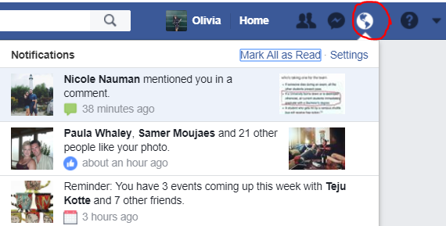

***Above: Figure 2***

* 1. To share a post on someone else’s page, first click on the ‘Share’ button below the post you wish to share. Next, click on ‘Share on a friend’s timeline’. A new box should pop up which allows you to search for the friend’s name you want to share the post with and also add a comment to your post. When you are satisfied, click on the ‘Post’ button. See Figure 3 for an example of what this pop up should look like.

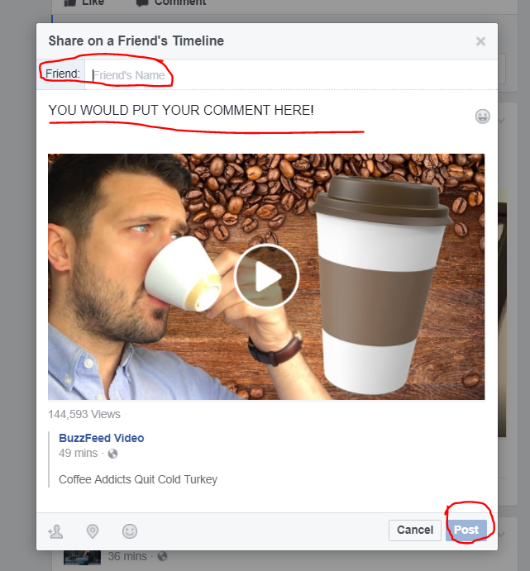

***Above: Figure 3***

* 1. To sell something in Marketplace, click on ‘Marketplace’ in the top left menu of the screen. See Figure 4 for an image of what this icon should look like. Next, click on the blue ‘+Sell’ button in the middle of the screen. A pop up should appear prompting you for information about the item you wish to sell. Note that it gives you the option to add photos. To do this, click ‘Add Photos’ and Navigate through your device to find the photos you wish to share. Fill in these blanks and then press ‘Post’. See Figure 5 for an example of this blank popup.

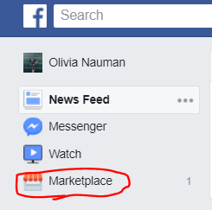

***Above: Figure 4***

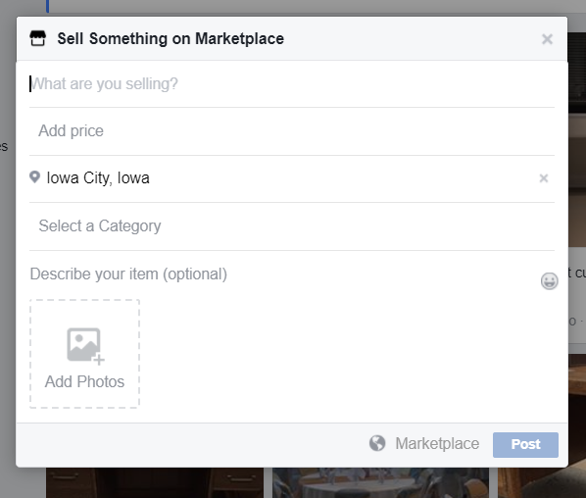

***Above: Figure 5***

1. 1. I think that Facebook effectively follows the design principle of visibility, because the icon is very clear and even features a ‘thumbs up’ symbol. This would also be an example of the usability principle ‘Aesthetic and Minimalistic Design’. Beyond that, the like symbol changes to ‘liked’ when you like the post to keep you knowing what is happening, which is a great display of both visibility and feedback. It doesn’t do a great job at the design principle ‘Constraints’. There are few things worse than accidentally liking a post of someone’s from a very long time ago when you are creeping through their profile. Maybe adding a pop up asking “are you sure?” would help with this.
   2. The Facebook method for checking notifications is, in my mind, not in alignment with the Usability Principle ‘Consistency and Standards’. When I think of a notification, an image of the earth is one of the last things I would think of; multiple other social media platforms use multiple other symbols as well. I also think it poorly displays the Design Principles ‘Visibility’ and ‘Feedback’ because after you press the notification icon, Facebook behaves as if you have acted on all of the notifications, when you likely have only interacted with one alert.
   3. The method for sharing a post on a friend’s timeline provides a great example of the design principle consistency because it is the same process as any other sharing across their site (on your own wall, in a group, in a personal message, etc.). Additionally, it is a good example of the Usability principle ‘Visibility of system status’ because it notifies you when the item has been shared.
   4. Facebook’s version of Marketplace follows the Design Principle Consistency because it requires a lot of similar information as Craigslist or other resale sites users are likely already familiar with. However, it is not a good example of ‘Constraints’ because it will let you sell any item for as expensive or cheap as you would like to, even if it is clearly not a reasonable price. (i.e. 2 billion dollars for a tablespoon of rice. )